**Name: Sanio Luke Sebastian**

**Roll No: 35**

**Batch: B**

**Date: 09-05-2022**

**NETWORKING & SYSTEM ADMINISTRATION LAB**

**Experiment No.: 10**

**Aim**

Familiarization of Shell Scripting programming to perform logical operations.

**Procedure**

1. Write a shell scripting program print the calendar of current date and current time./\

**Code:**

#!/bin/bash

echo "The current date is : "$(date)

echo ""

echo "The current calender is : "

cal

**Output:**

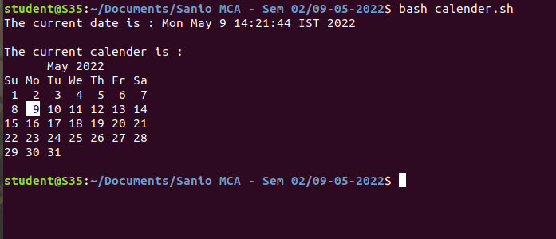

1. Write a shell scripting program to check the greatest between two numbers using logical operators.

**Code:**

#!/bin/bash

echo "Enter the number 01 : "

read a

echo "Enter the number 02 : "

read b

if [ $a -gt $b ]

then

echo "Number 01=$a is greater."

elif [ $a -lt $b ]

then

echo "Number 02=$b is greater."

else

echo "Both the numbers i.e. $a are the equal."

fi

**Output:**

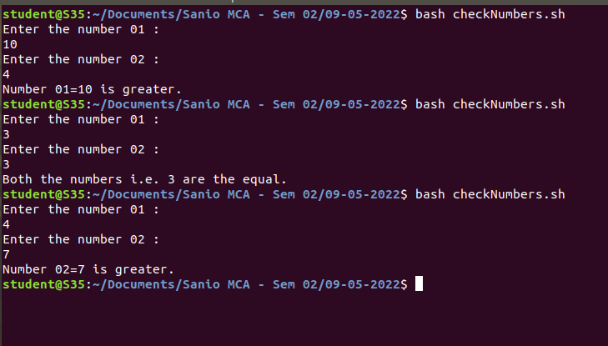

1. Write a shell scripting program to find the sum of the sum of first N numbers using for loop.

**Code:**

#!/bin/bash

sum=0

for (( i=1; i<=10; i++ ))

do

sum=`expr $sum + $i`;

done

echo "The sum of first 10 numbers is : "$sum

**Output:**

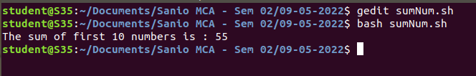

1. Write a shell scripting program to find the sum, average and product of four numbers.

**Code:**

#!/bin/bash

echo "Enter the num 01 : "

read a

echo "Enter the num 02 : "

read b

echo "Enter the num 03 : "

read c

echo "Enter the num 04 : "

read d

sum=`expr $a + $b + $c + $d`

avg=$(echo "scale=2;$sum / 4" | bc -l)

product=`expr $a \* $b \* $c \* $d`

echo "The sum of the given integers is : $sum"

echo "The average of the given integers is : $avg"

echo "The product of the given integers is : $product"

**Output:**

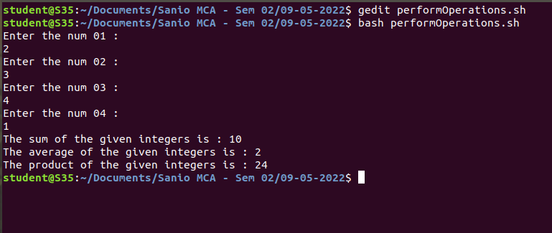

1. Write a shell scripting program to find the factorial of N numbers.

**Code:**

#!/bin/bash

echo "Enter the number : "

read a

fact=1

for (( i=1; i<=a; i++ ))

do

fact=`expr $fact \* $i`

done

echo "The factorial of the given number i.e. $a is : $fact"

**Output:**

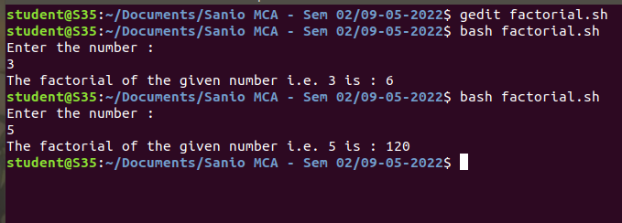

1. Write a shell scripting program to check the palindrome of a given number.

**Code:**

#!/bin/bash

echo "Enter the number to check the palindrome : "

read n

temp=$n

rev=0

while [ $n -gt 0 ]

do

rev=$(expr $rev \* 10)

rem=$(expr $n % 10)

rev=$(expr $rev + $rem)

n=$(expr $n / 10)

done

#echo $rev

if [ $temp -eq $rev ]

then

echo "The number is a palindrome number"

else

echo "The number is not a palindrome number"

fi

**Output:**

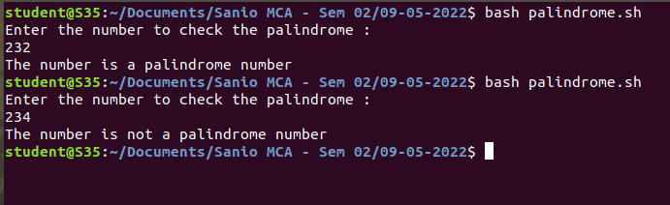

1. Write a shell scripting program to find the leap year within the given range.

**Code:**

#!/bin/bash

echo "Enter the year to check for leap year: "

read year

a=$(($year%4))

b=$(($year%100))

c=$(($year%400))

if [ $a -eq 0 -a $b -ne 0 -o $c -eq 0 ]

then

echo "The entered year is a leap year."

else

echo "The entered year is not a leap year."

Fi

**Output:**

